Final Project Week 4 Manual Test Plan

This is a manual test plan that provides guide to install environment for, to run, and to test the React project in week 4 of final project.

**Prerequisites**

* React
* PyCharm

**Environment Setup**

The flask program file is ‘novel_api_2.py’ (It fetches data from a different mongodb collection than ‘novel_api.py’, which does not contain extra information such as chapters).

The main program file is ‘app.js’ and ‘index.js’.

‘app.js’ renders the component of ‘main_layout.js’.

‘main_layout.js’ renders four components from ‘gallery.js’, ‘control_bar.js’, ‘filters.js’, and ‘search_bar.js’.

‘gallery.js’ filters novels and pass filtered novels to ‘gallery_display.js’.

‘control_bar.js’ contain a ‘quiz’ button that will navigate to the quiz page on click. Users can take a quiz of what kind of novel they want to read and get recommended novels.

Packages include react-custom-scrollbars, and react-icons.

These packages can be installed using npm.

**Manual Tests**

Start local API server in PyCharm to return all novels in database.

When our flask program name is ‘novel_api_2.py’, type following commands in the command line to start flask app:

set flask_app=novel_api_2.py

flask run

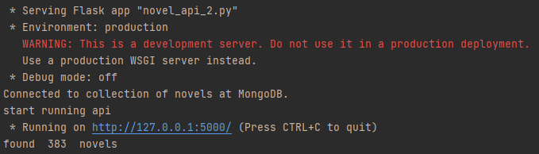

Then, go to the folder of the React app, use ‘npm install’ to install packages and ‘npm start’ to run.

If the program runs successfully, a web page will automatically open at url: localhost:3000, and the following screen will show up:

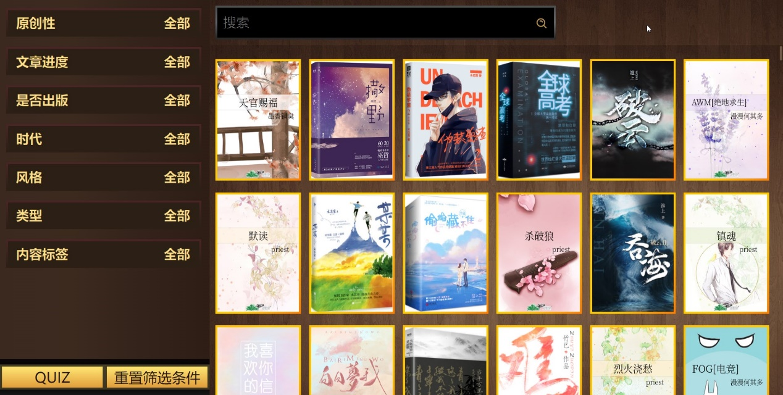

After clicking the QUIZ button at the left lower corner, the app will navigate to /quiz route, showing the UI as below:

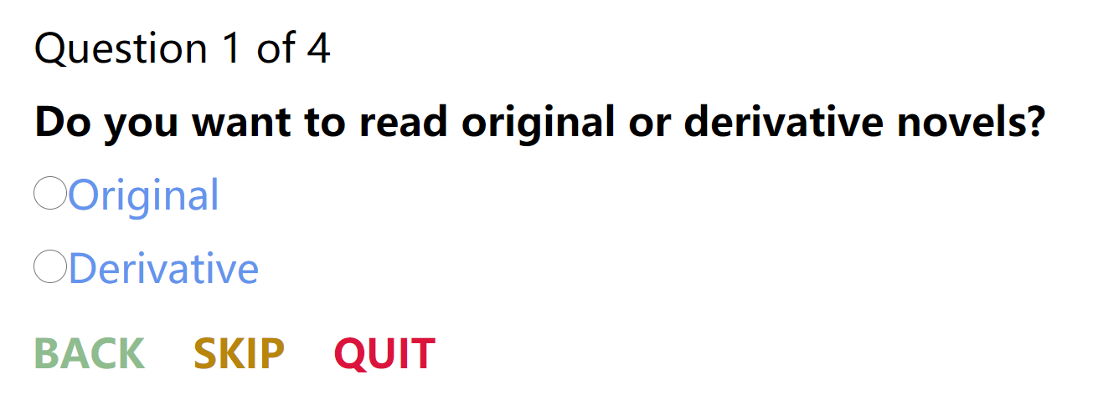

Users can click on ‘Original’ to go to the next question:

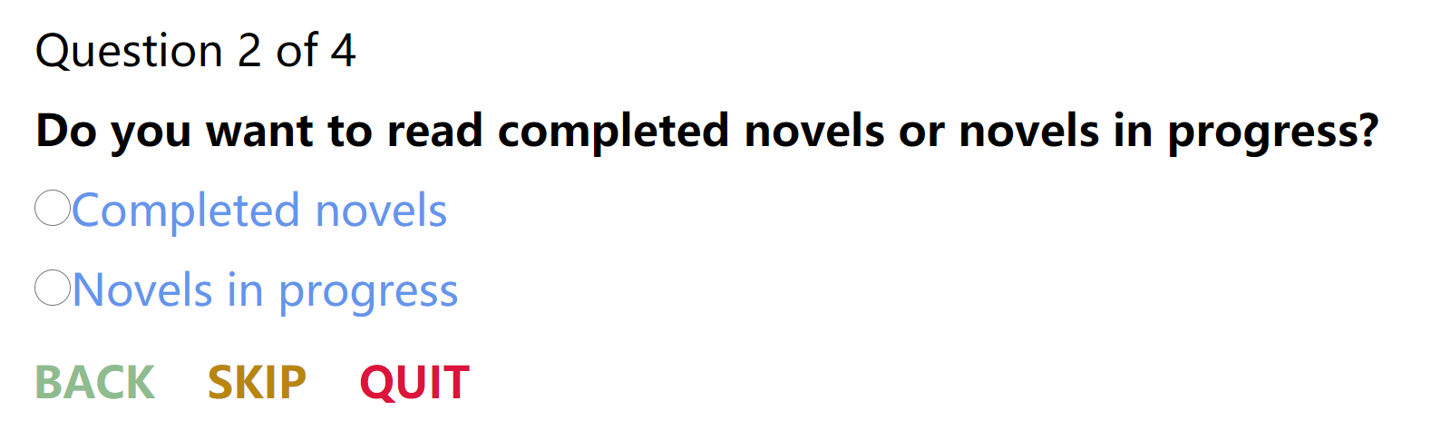

After answering all questions, a button will appear on the screen:

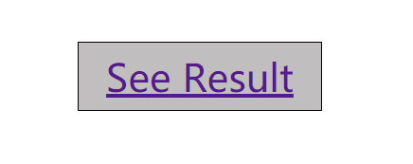

After clicking the ‘See Result’ button, the app will navigate back to the home screen, filters will appear according to quiz answers, and the gallery will show suitable novels:

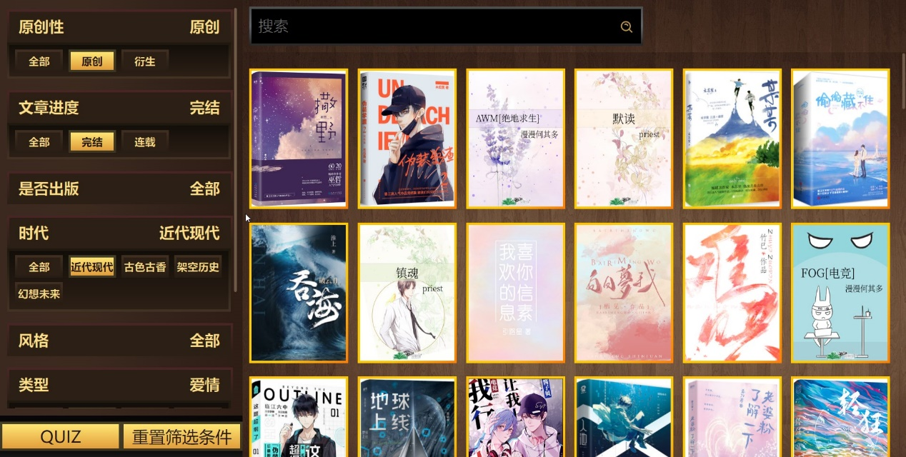

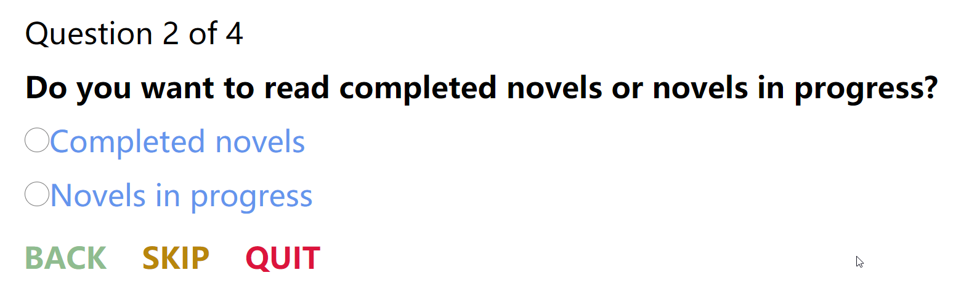

If users are not satisfied with their answer to the previous question, they can click the BACK button to go back to the previous question and redo it.

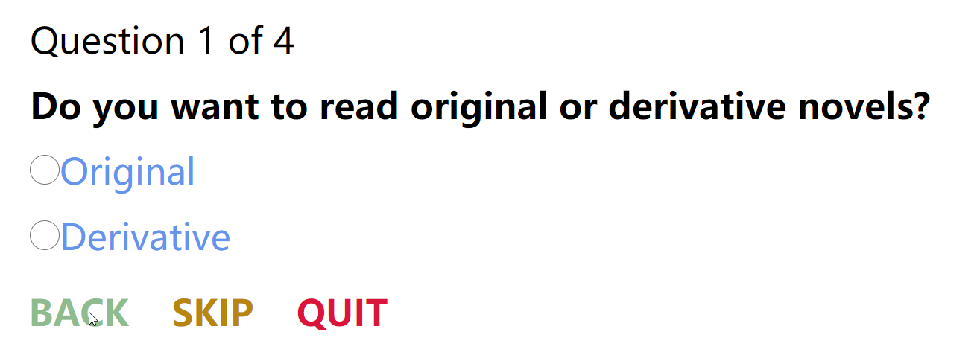

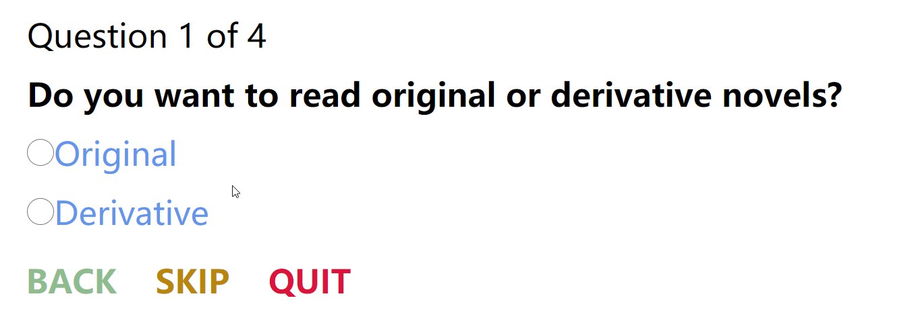

If users are not sure about their answer to a question or they just do not care, they can click the SKIP button to jump to next question. The filter will appear as ‘全选’ later, meaning that the skipped filter will not filter any novel.

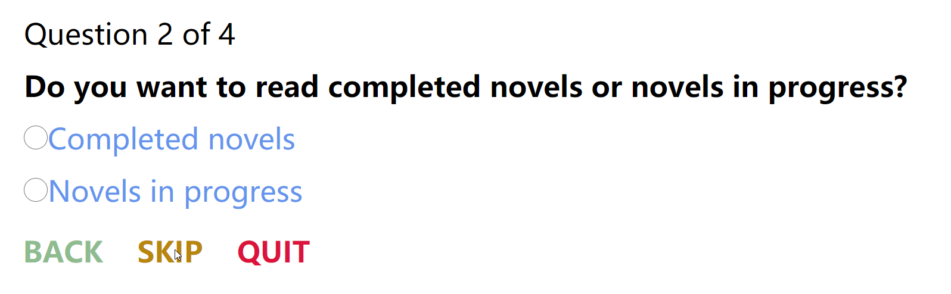

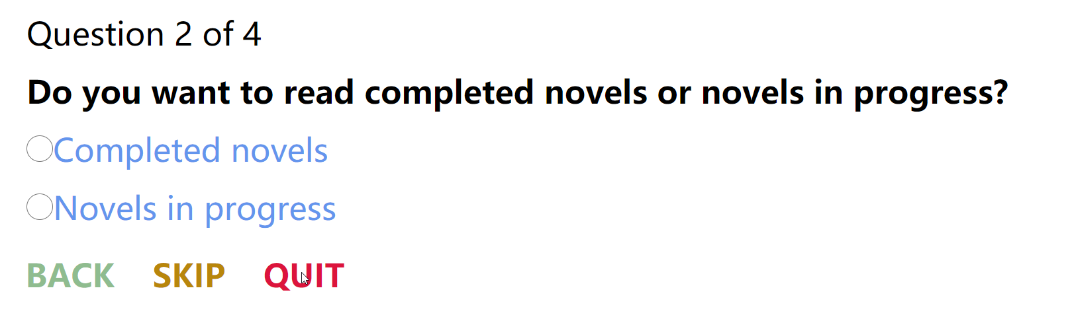

If a user chose ‘Original’ for the first question, and does not feel like answering the rest questions, he or she can click the QUIT button, and click ‘See Result’, to go to the home page. Only the Originality filter will filter on novels according to the quiz result.

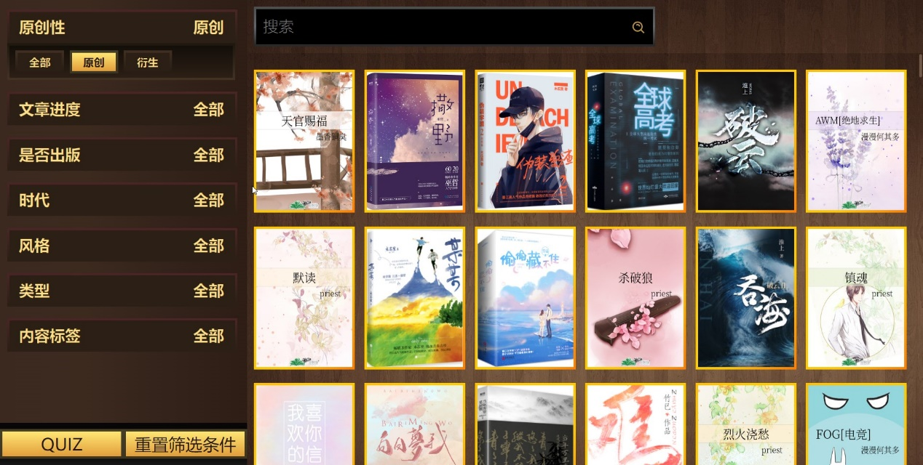

When hovering on a recommended novel, a information box will appear, including novel title, author, one-sentence description, style, ranking, word count, and content labels.

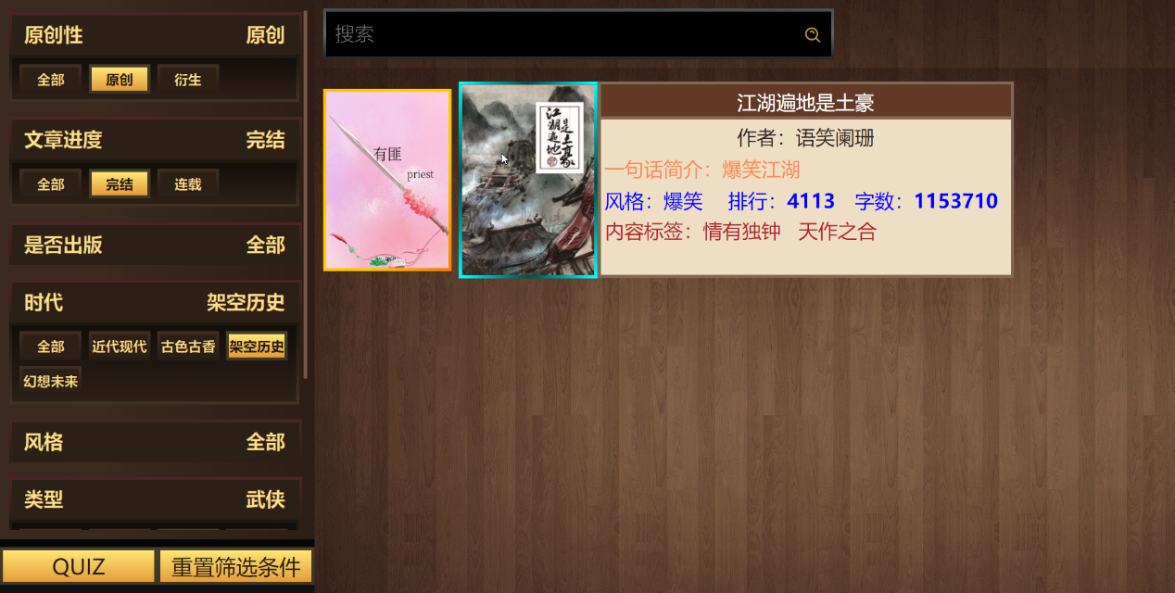

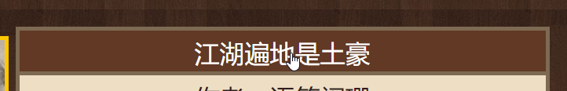

After hovering on the information box, users can click on the novel title to go to the original novel website.

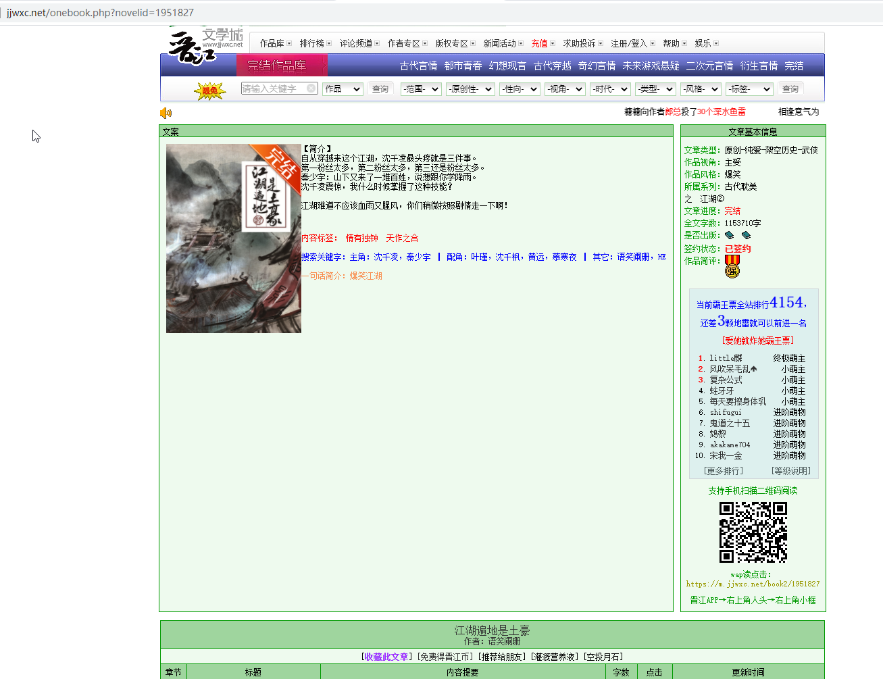

Similarly, users can click on the author name to go to the original author website.

